Título

Kinectulum

3D Object reconstruction using Kinect and mirrors

3D Object reconstruction using a single Kinect and mirrors

3D Image Acquisition using a Static Setup

3D Information Acquisition of Small Daily Objects

3D Full Data Acquisition a Static Setup

3D Panoramic Data Acquisition using a Static Setup

3D Concentric Data Acquisition using a Static Setup

Head

Thanks

Things

Abstract

Things

What did you do?

Why did you do it? What question were you trying to answer?

How did you do it? State methods.

What did you learn? State major results.

Why does it matter? Point out at least one significant implication.

Resumo

­Introduction

Description of the problem here.

The acquisition of 3D information is classically a difficult and slow process. The usage of RGB cameras alone is not efficient neither precise once we only have the image in 2D and the extraction of 3D information has to be calculated through computer vision algorithms. With the addiction of other material such as projectors and with the application of technics as structured light, the acquisition has become more precise but it requires more time.

3D acquisition systems as structured light have high costs.

With the introduction of depth cameras such as the Kinect, the acquisition of the 3D information became easier and in real time. Nevertheless, the acquisition does not have a high level of detail due to the cameras’ resolution but if we combine the raw image information with computer vision algorithms for image treating and 3D reconstruction, we can achieve good results regarding quality and performance.

The idea is to take advantage of the potential of the Kinect and use as much information as we can. Typically, when aiming at an object with a camera, we center this object and there is much space of the image that doesn’t have useful information. If we could use this space to acquire information about this object, we would be maximizing the resources and as so, we can achieve better results in less time.

We live in a world more and more digital where the interaction between humans and technology and more specifically, computers, is more and more common.

The interaction between humans and technology and, more specifically, computers, is more and more frequent.

Motivation

Challenge to build a system capable of concentric acquisition using a static setup and only one camera without having to move it around. Better acquisition in less time.

Minimize the system’s cost.

Creation of 3D information and potential connection to 3D printers, videos and eventually, holography.

What can be the utility of this system?

Objectives

Document Organization

Related Work

3D Scanning / Images Acquisition

Things

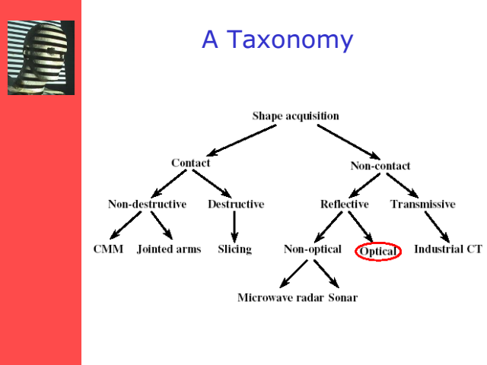

Ilustração 1 - Structured Lighting (Talk - 2012)~

“Consumer RGB-D Cameras and their Applications”

Stereoscopy

Things

Structured Light

Things

Time-Of-Flight

See Book Time-of-Flight Cameras and Microsoft Kinect

Things

Kinect

Things

See Book Time-of-Flight Cameras and Microsoft Kinect

Panoramic Data Acquisition Systems

Things

Moving

Things

Static

Things

­­­­­­­Summary

Things

Concept Design (?)

Re-explain the problem and show some example of what it would be nice to do with it.

Drain from objectives: Static Setup, concentric and real-time acquisition, low-cost.

First we will show the system (how the system was built and structured) and then explain the decisions of the chosen technologies and methodologies.

System Overview

Quick overview of the System: Image of the physical architecture, brief description of the *modus operandi.*

Decisions

For each part of the system explain the reason of that choice.

Data Acquisition

**Criteria for Decisions**

Why use Kinect.

Low cost, static setup, Real-time

Concentric (Acquisition) Setup

**Criteria for Decisions**

Low cost, static setup, Real-time

As previously shown, the built system will make use of mirrors in the periphery of the camera’s image to achieve the concentric setup

Why to use mirrors (cheap and static system, no moving around with the camera)

System Design / System Architecture and Functionalities

Extended overview of the system.

Architecture

Show the proposed system (architecture).

Image of the System and explanation of the use of one camera and N mirrors (configurable)

Functionalities

Single Object Acquisition

Real-time Acquisition

Development

System pipeline

If necessary, show some specific parts of the code or implemented algorithms.

Setup

Setup “Manual” referred to Appendix?

Point Cloud Acquisition

Mirrors and Floor differences

Mesh Generation

Smoothing (where?)

Data Visualization / Recording

Problems and Solutions

Noise

Distance filtering

Floor removal

Hole filling

“Multiple Kinect Studies - Technical Report”

“DEPTH CAMERA IMAGE PROCESSING AND APPLICATIONS” - In this paper, we introduce various systematic and non-systematic depth errors and state of the art enhancement methods

“Incremental 3D Model Generation using Depth Camera” - we propose a method of retaining knowledge of surfaces from depth camera images acquired over time

Technology

Used Technologies: OpenNI, OpenCV, (C++)

Kinect for windows Near Mode –

http://blogs.msdn.com/b/kinectforwindows/archive/2012/01/20/near-mode-what-it-is-and-isn-t.aspx

Results

Object Acquisition

Show examples of Point Clouds and Meshes.

Continuous acquisition for missing data

Hole filtering technics/3D processing

Real-time Acquisition

Show examples of Point Clouds videos and Fast Mesh Generation

Quality analysis

Performance Analysis.

Conclusion and Future Work

Conclusions

Future Work

Use of Leap Motion – Show the advantages of Leap and a possible integration with a RGB camera to complement depth and rgb image.

Appendix

User Guide

Related Work

3D Scanning / Images Aquisition

Things

Technology (Instruments)

Describe each technology and point the pros and cons.

Structured Light

Stratified light?

Depth Cameras (emphasis on Kinect)

Ranging Cameras

Triangulation Scanners

**Mesa Imaging SwissRanger 4000 (SR4000)**

<http://www.acroname.com/robotics/parts/R317-SR4000-CW.html>

**PMD Technologies CamCube 2.0**

http://www.geometh.ethz.ch/people/kohtobia/DGPF2011

<http://openni-discussions.979934.n3.nabble.com/OpenNI-dev-Minimum-Depth-td4015339.html>

**PMD Nano**

http://www.pmdtec.com/html/pdf/order_CamBoard_nano.pdf

**Bumblebee 2 e XB3 specs**

http://uprt.vscht.cz/kubicekm/Novinky%20ze%20sv%C4%9Bta/Stereo_Vision_Introduction_and_Applications.pdf

**Bumblebee 2**

http://3dvision-blog.com/forum/viewtopic.php?f=23&t=2655

**Bumblebee XB3**

http://www.ece.gatech.edu/academic/courses/ece4007/11fall/ECE4007GTS/sv1/documents/ASEDProposal.pdf

**Kinect**

**Primesence**

**Other Cameras**

<http://en.wikipedia.org/wiki/Time-of-flight_camera#Brands>

<http://dinast.com/ipa-1110-cyclopes-ii/>

http://www.3d3solutions.com/products/3d-scanner/

Systems

Show some examples of working systems. Point the technologies that they use, their characteristics and for what purposes where they developed and explain how they are used (static or moving camera, p.e.)

From Capture to Models

Mesh construction from point clouds.

Smoothing

Color issue.

Normal, reflection, etc.

­­­­­­­Summary

Things